Homework Week #9

(20 points total)

Using what you’ve learned so far in the course, specifically during week 9, answer the following questions.

Question 1: (2 points) List 4 functions of the **sed** editor?

**Deleting – sed ‘2d’ data.txt**

**Inserting – sed ‘i\**

**Appending – sed ‘3a\**

**Changing – sed ‘2c\**

Question 2: (1 point) True or False: The positional parameters $0, $1, etc. have the very similar meaning when used with a **gawk** editior. Explain.

This is **true**. Positional parameters can be in awk. Gawk is just GNU awk.

Question 3: (7 points) List 14 different special characters within POSIX BER Regular Expression engine.

**Plain Text – echo “My name is Rich” | sed -n ‘/Rich/p’**

**Anchors – sed -n ‘/^start and end$/p’ data.txt**

**dot Character – sed -n ‘/.at/p’ data.txt**

**Character Classes – sed -n ‘/[ch]at/p’ data.txt**

**Negating Character – sed -n ‘/[^ch]at/p’ data.txt**

**Ranges – sed -n ‘/[c-h]at/p’ data.txt**

**Special Classes – sed -n ‘/[[:digit:]]/p’ data.txt**

**Asterisk Character – sed -n ‘/bo*t/p’ data.txt**

**Question Mark – gawk ‘/bo?t/ {print $0}’**

**Plus Sign – gawk ‘/bo+t/ {print $0}’**

**Using Braces – m: gawk ‘/bo{1}t/ {print $0}’**

**m, n: gawk ‘/bo{1, 2}t/ {print $0}’**

**Pipe Symbol – gawk ‘/bot|boot/ {print $0}’**

**Grouping Expression – gawk ‘/Sat (urday) ?/ {print $0}’**

Question 4: (4 points) Using the **sed** editor show two (2) different command line arguments that would read data from a file **myfile.txt** and insert after the second line of text in **mydata.txt.**

**myfile.txt** First new line

Second new line

**sed ‘3r myfile.txt’ <mydata.txt> temp.txt**

**mv temp.txt mydata.txt**

**mydata.txt** Line number 1

Line number 2

Line number 3

Line number 4

For questions 5-8 use the file “data.txt” from canvas week 9 as the input file. For each question submit the **sed** command used and the resulting output. Note: Start with a fresh copy of data.txt for each question.

Question 5. (1 point) Change the file to replace periods at the end of a sentence with exclamation points.

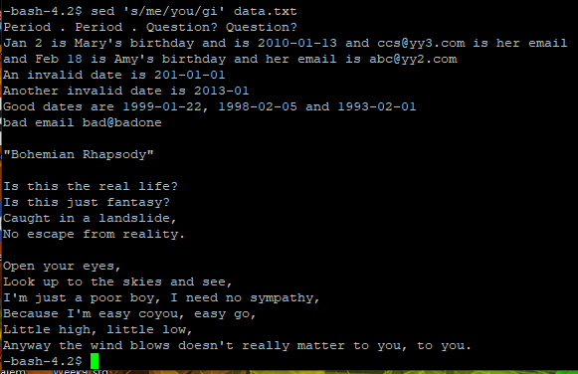

Question 6. (1 points) Replace every occurrence of the word 'me' with 'you', but be sure that replace is not case sensitive. 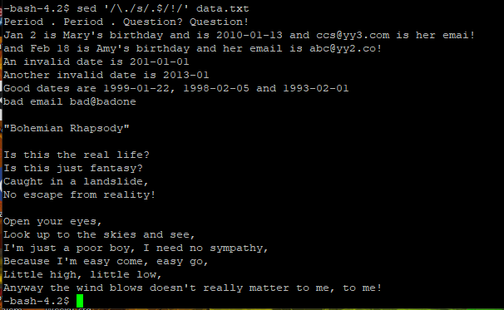

Question 7. (2 points) Display only the dates, in the format YYYY-MM-DD, from the file. You only need to print one occurrence of this pattern per line.

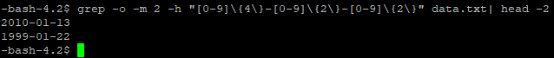

Question 8. (2 points) Display email addresses, formatted as xxx@xxx.xxx, from the entire file. You only need to pull one per line.

